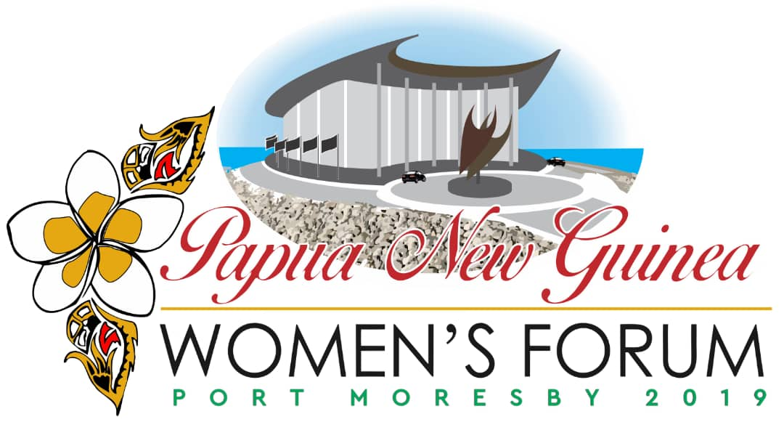

NCD Regional Forum, Port Moresby
November 6-7, 2019

Instructions for Public Application Form

Women serving in leadership roles within community and civil society groups, individual women leaders and women’s empowerment advocates, female business owners, emerging young leaders, up and coming public servants, and other leading women in Papua New Guinea should use this form to apply to participate in the 2019 PNG Women’s Forum. You may apply for yourself or other women who are interested in attending. Men with a strong interest in women’s empowerment and/or gender equality may also apply.

Applications are due by Friday, October 18, 2019 and can be submitted by e-mail, fax, mail, or hand delivered. Please submit completed applications to any of these locations:

U.S. Embassy Port Moresby (Attention: Agatha Pio), Douglas Street, Town, Port Moresby (across from
Deloitte Tower), e-mail: econportmoresby@state.gov Phone: +675-321-1455, ext. 2211; Fax: +675-321-1593

PNGWBRC, Hohola (Attention: Eli Webb), Century 21 Haus, Kunai Street, Hohola, Port Moresby (same street as MVIL), e-mail: PNGEvents@cipe.org Phone: +675-7043-0788 (Digi), +675-7649-0469 (B-Mob)

Applications are now open, and will close on 18 October 2019.
Beginning on October 21st, 2019, applicants will be informed of their acceptance to participate in the 2019 PNG Women’s Forum, Port Moresby. Attendance is FREE but spaces are limited.
If you do not have access to e-mail, fax, or are unable to turn in the application form by mail or in person, applications may be called in over the phone (be prepared to read your completed application information to our staff over the phone).

We encourage diverse participation at the forum; however, due to limited funding, sponsored travel and accommodation cannot be awarded to everyone. Applicants are encouraged to include a narrative bio that gives a snapshot of her/his skills, qualifications, and interests, and explain why she/he is interested in attending the Forum. These will be the key components used to select participants to attend the Forum and for sponsored travel.
NCD Regional Forum
Port Moresby
November 6-7, 2019

Public Application Form

1. Applicant’s Contact Information

Name of Applicant:
_________________________________________________________________________________________
Applicant’s date of birth:
__________________________________________________________________________________________
Applicant’s email address:
__________________________________________________________________________________________ Applicant’s office and mobile telephone number(s):
__________________________________________________________________________________________

2. Type of Applicant

Please select the category that best fits the Applicant (choose only one).
☐ Leader within Community Group/Civil Society Group
☐ Individual Interested in Women’s Empowerment (not affiliated with any group)
☐ Business Owner
☐ Emerging Young Leader (under 30)
☐ Up and Coming Public Servant (working for the government)
☐ Other: _________________________________

3. Applicant’s Educational Background (if applicable)

Name and location of Institution:
________________________________________________________________________________________

Qualifications:______________________________________________________________________________

4. Applicant’s Current Employment Information (if applicable)

Name and location of Employer:
__________________________________________________________________________________________
Job Title:
__________________________________________________________________________________________ Number of Years at This Job:
__________________________________________________________________________________________

5. Interest in Sponsored Travel

Would the Applicant like to be considered for sponsored travel? If yes, please indicate whether s/he would like to be considered for sponsored ground transport, lodging, or both.

☐ Yes, consider the Applicant for sponsored ground transport to/from Port Moresby
(only applicable if the applicant lives outside Port Moresby)
Please write the length and roundtrip cost of the drive from the applicant’s hometown to Port Moresby:

Length of drive: ____________________________ Cost: _______________________

☐ Yes, consider the Applicant for sponsored lodging during the forum in Port Moresby.

Sponsored travel and lodging is not guaranteed. There are limited slots available for sponsored travel, and these will be assigned on a competitive basis (primarily based upon the applicant’s record of community involvement). Sponsored travel will not include reimbursement for food or other incidentals.

6. Participation in Previous PNG Women’s Forums

Has the Applicant participated in previous PNG Women’s Forums? If so, what year?
☐ Yes, the Applicant attended the PNG Women’s Forum in the following year(s): ________________________

7. Applicant’s Biographic Information

Please provide a brief bio that notes any community involvement. Also, describe why the applicant should attend the NCD Regional Women’s Forum and how the applicant’s organisation would benefit from the applicant attendance at the forum. Of particular importance, is the applicant’s commitment to advancing the role of women in PNG, the applicant’s goals and potential to achieve change within her community and any professional or social networks in which the applicant participates.
__________________________________________________________________________________________
__________________________________________________________________________________________
__________________________________________________________________________________________
__________________________________________________________________________________________ __________________________________________________________________________________________
__________________________________________________________________________________________ __________________________________________________________________________________________ __________________________________________________________________________________________
__________________________________________________________________________________________ __________________________________________________________________________________________
__________________________________________________________________________________________
__________________________________________________________________________________________ __________________________________________________________________________________________ __________________________________________________________________________________________
__________________________________________________________________________________________ __________________________________________________________________________________________ __________________________________________________________________________________________
__________________________________________________________________________________________
__________________________________________________________________________________________
__________________________________________________________________________________________
__________________________________________________________________________________________ __________________________________________________________________________________________
__________________________________________________________________________________________

8. Survey

We want to hear from you! Help shape the Annual PNG Women’s Forum!

What topics would you like to discuss at the 2019 Annual PNG Women’s Forum?

_______________________________________________________________________________________
_______________________________________________________________________________________ _______________________________________________________________________________________

By completing this form, you agree to allow your information listed in the directory of PNG Women’s Organisations.

